## Placeholder image

PHP PROJECT DOCUMENTATION

Online Movie Booking System

**(Batch: 2010B3)**

19.5.2022

**─**

**PROJECT** **SUBMITTED BY**

|  |  |
| --- | --- |
| Student1278398 | MUHAMMAD IRFAN . |
| Student1278149 | JUNAID GHANI |
| Student1274232 | HAMZA SIDDIQUI |
| Student1204067 | WAHAJ BIN AHMED |

# 

**Project Instructor Miss Hina Siddiqui**

**Batch Code 2010B3**

# 

**TABLE OF CONTENTS**

[**ACKNOWLEGDMENT**](https://docs.google.com/document/d/1gYRJ0rnOP2PjWNCVZ0Q_QOvIVRt-9kx1Cw6n12Y9lFY/edit#heading=h.gjdgxs) **3**

[**PROJECT CERTIFICATION**](https://docs.google.com/document/d/1gYRJ0rnOP2PjWNCVZ0Q_QOvIVRt-9kx1Cw6n12Y9lFY/edit#heading=h.30j0zll)  **4**

[**INTRODUCTION TO CELLINFO**](https://docs.google.com/document/d/1gYRJ0rnOP2PjWNCVZ0Q_QOvIVRt-9kx1Cw6n12Y9lFY/edit#heading=h.1fob9te)  **5**

[**REQUIRMENT SPECIFICATION**](https://docs.google.com/document/d/1gYRJ0rnOP2PjWNCVZ0Q_QOvIVRt-9kx1Cw6n12Y9lFY/edit#heading=h.3znysh7)  **6**

[**(A) HARDWARE REQUIRMENT**](https://docs.google.com/document/d/1gYRJ0rnOP2PjWNCVZ0Q_QOvIVRt-9kx1Cw6n12Y9lFY/edit#heading=h.2et92p0)  **7**

[**(B) SOFTWARE REQUIRMENT**](https://docs.google.com/document/d/1gYRJ0rnOP2PjWNCVZ0Q_QOvIVRt-9kx1Cw6n12Y9lFY/edit#heading=h.tyjcwt)  **8**

[**PROJECT DURATION**](https://docs.google.com/document/d/1gYRJ0rnOP2PjWNCVZ0Q_QOvIVRt-9kx1Cw6n12Y9lFY/edit#heading=h.gjdgxs)  **9**

[**SNAPSHOT**](https://docs.google.com/document/d/1gYRJ0rnOP2PjWNCVZ0Q_QOvIVRt-9kx1Cw6n12Y9lFY/edit#heading=h.1fob9te) **10**

**ACKNOWLEDGEMENT**

I am thankful to Almighty, ALLAH that by His grace we have been successful. I have tried my best to take all relevant important topics in consideration so that this project may become comprehensive.

This is My Third Semester PHP-project. I have tried my best & struggled for a better outlook to come. This project has been developed in PHP. I make Web Development Project for Online Movie Booking System as a project. I find easy to do coding in Visual Studio Code.

I earnestly hope that this project will provide all the necessarily information required for the user to fulfill their inspiration. However suggestions for improvement of the project will be thankful received & acknowledge.

**PROJECT CERTIFICATION**

**This is to certify that,**

Has Successfully Designed & Developed:

|  |  |
| --- | --- |
| Student1278398 | MUHAMMAD IRFAN . |
| Student1278149 | JUNAID GHANI |
| Student1274232 | HAMZA SIDDIQUI |
| Student1204067 | WAHAJ BIN AHMED |

Online Movie Booking System PHP project

**Date of issue:**

19.05.2022

# HARDWARE / SOFTWARE REQUIRMENTS

**Hardware**

* A minimum computer system that will help you access all the tools in the courses is a Pentium 166 or better
* 64 Megabytes of RAM or better

**Software**

* Xampp Control panel
* Visual Studio Code

|  |  |  |
| --- | --- | --- |
| No. | Items | Description |
| 1 | Operating System | Window 8.1 ,10 etc. |
| 2 | Main processor | Minimum 166 or better |
| 3 | Ram (Memory) | Minimum64 or better |
| 4 | Software | Xampp Control panel  Visual Studio Code |

**PROJECT DESCRIPTION**

**PROJECT DESCRIPTION**

Online Movie Booking System Has Two Interfaces I.E. User Interface and Administrator Interface.

**List of Validation**

|  |  |
| --- | --- |
| **Option** | **Validation** |
| Suitable logo on main page | Yes |
| Proper menu | Yes |
| All product details download in word docs | Yes |
| Various pages have details about products | Yes |
| Contact us page | Yes |
| Products are properly categorized | Yes |

**System Estimates and Actual Outcome**

**Estimation of time for the software:**

|  |  |
| --- | --- |
| **Estimation Of time** | **Days** |
| Researching and information collecting period | 2 days |
| Analyzing other software and tools | 1 day |
| Formation of website | 27 days |
| Duration of Report | 25 days (simultaneously with project) |
| **Total time** | 30 days |

**Actual time for the software:**

|  |  |
| --- | --- |
| **Actual time** | **Days** |
| Researching and information collecting period | 1 and 1/2 days |
| Analyzing other software and tools | 1/2 day |
| Formation of website | 28 days |
| Duration of Report | 23 days (simultaneously with project) |
| **Total time** | 30 days |

SCREEN SHOTS OF

Online Movie Booking System

# Home Page:

Here User Can View All the Users and Can Also View Other Users Details, Just Click on One Of The users Icon, Which Are Appeared on The View All Users

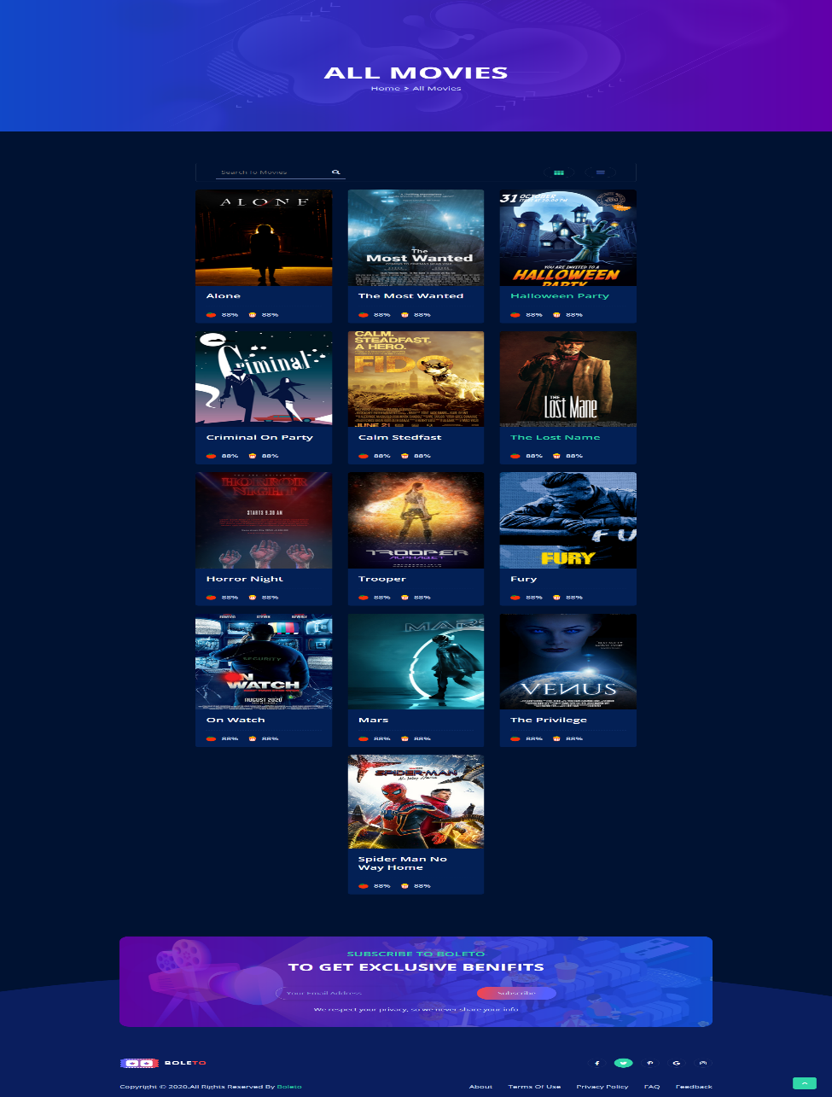

# About Page:

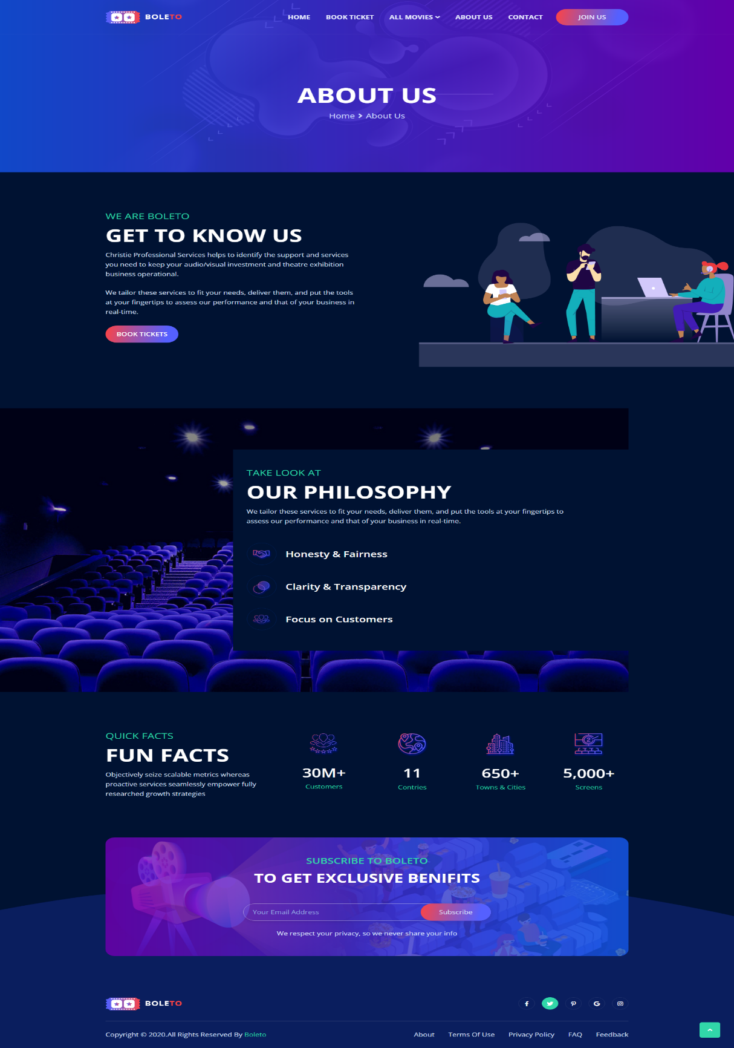

# Contact Us Page:

This Is Contact page User Can Contact Admin by Composing Mail

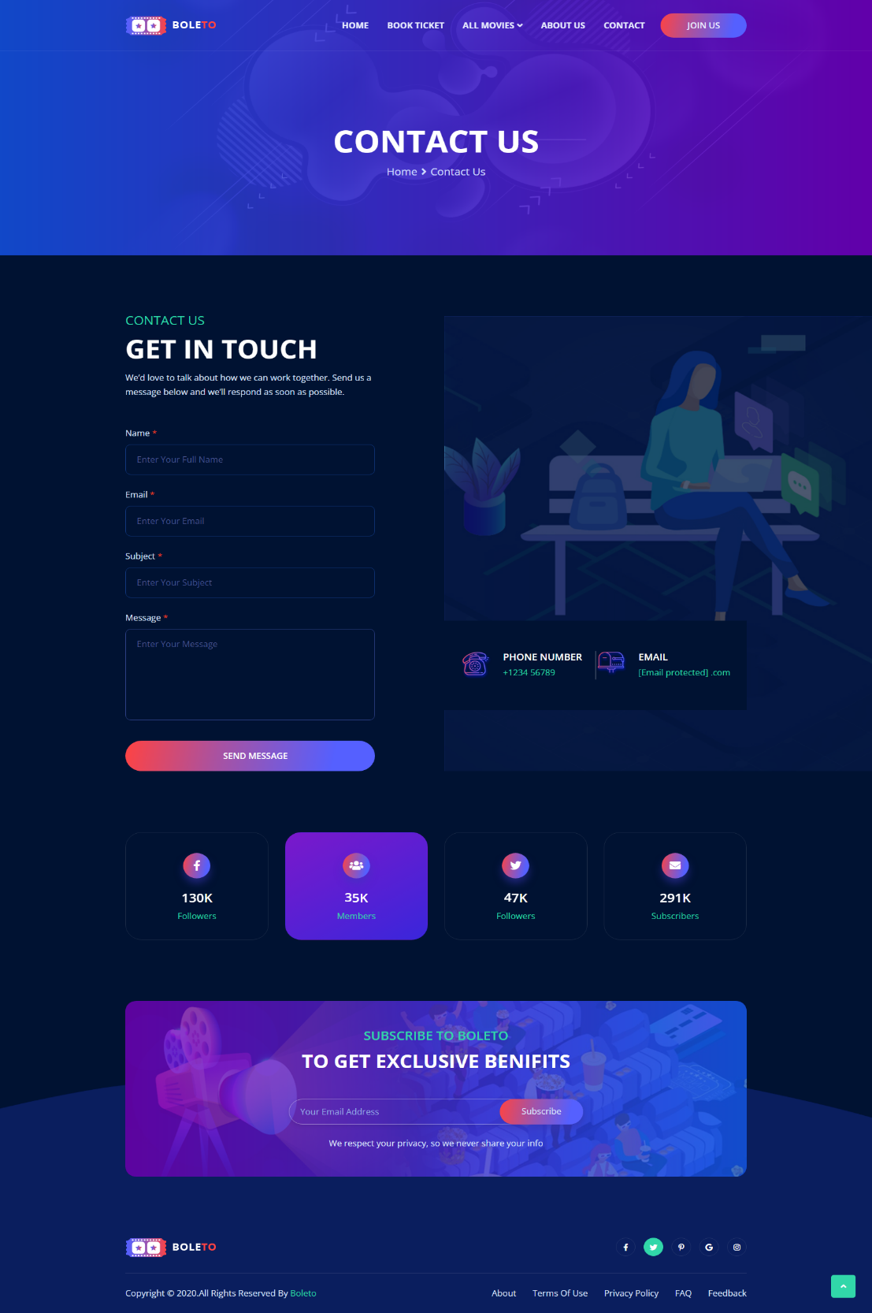

# Signup Page:

After Signup, User have to verify Its Gmail Account and Admin Approval Is Also Needed.

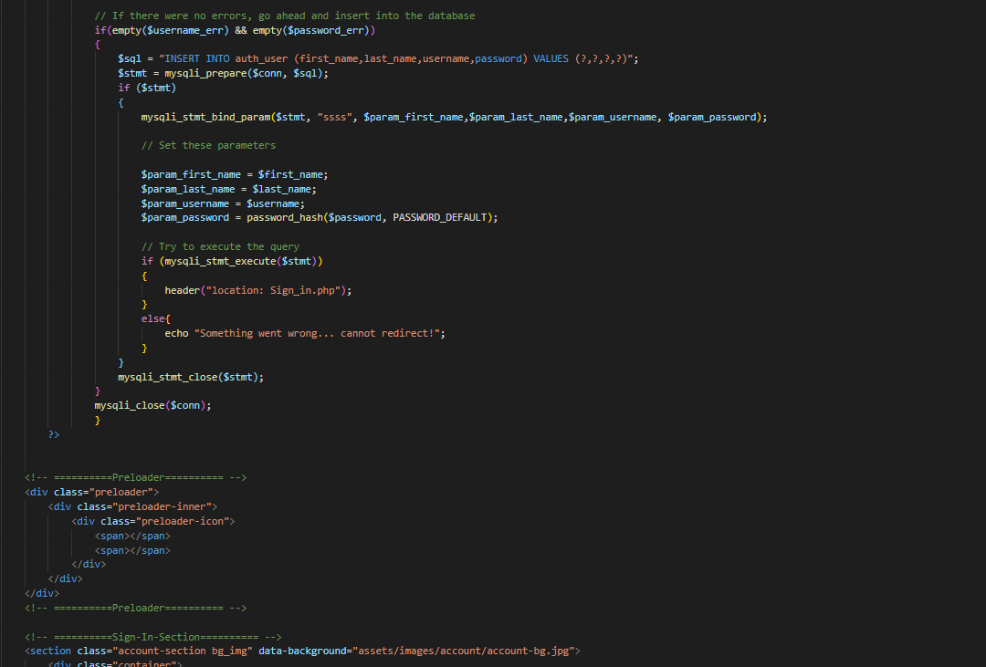

# Login Page:

Before Login, User Have To Verify Its Gmail Account Then Admin Approved Its Request Then Securely Login.

# Admin Panel:

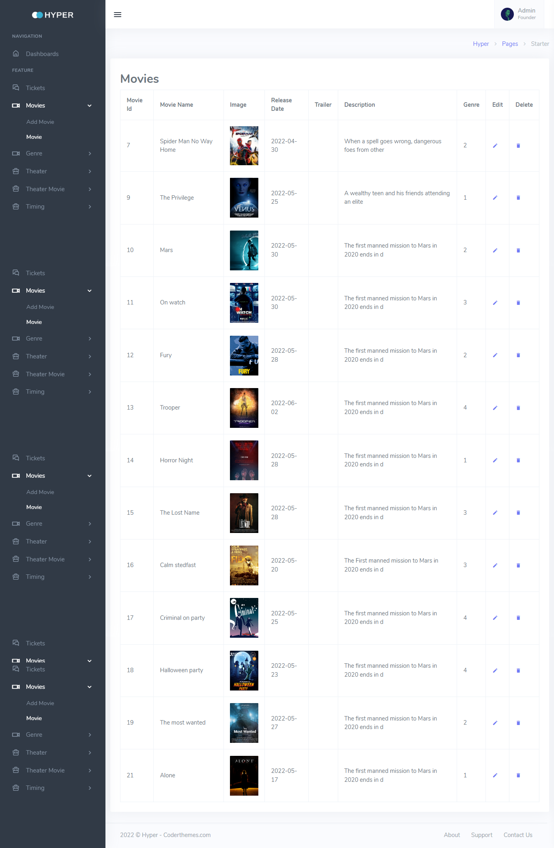

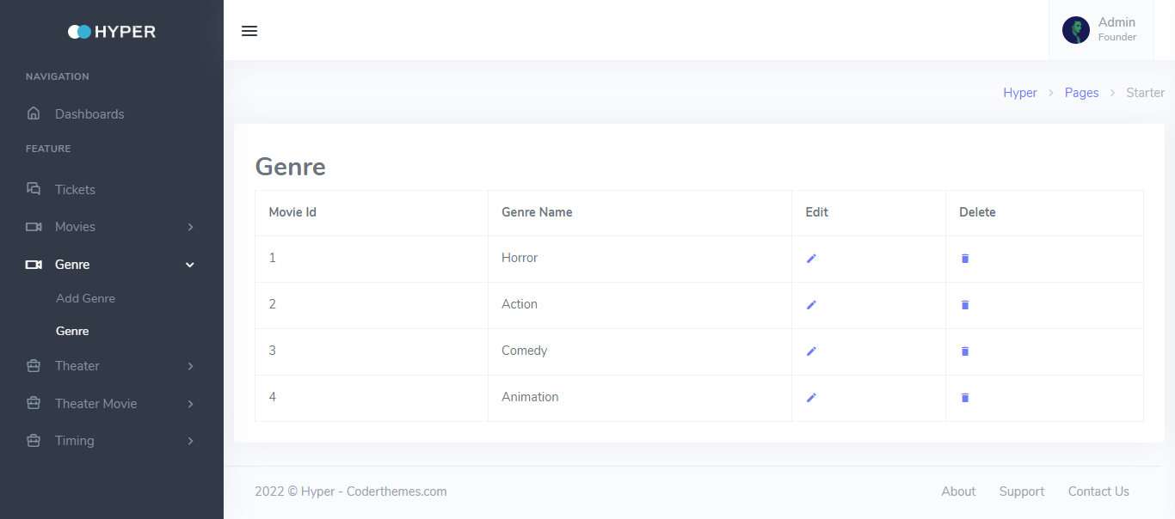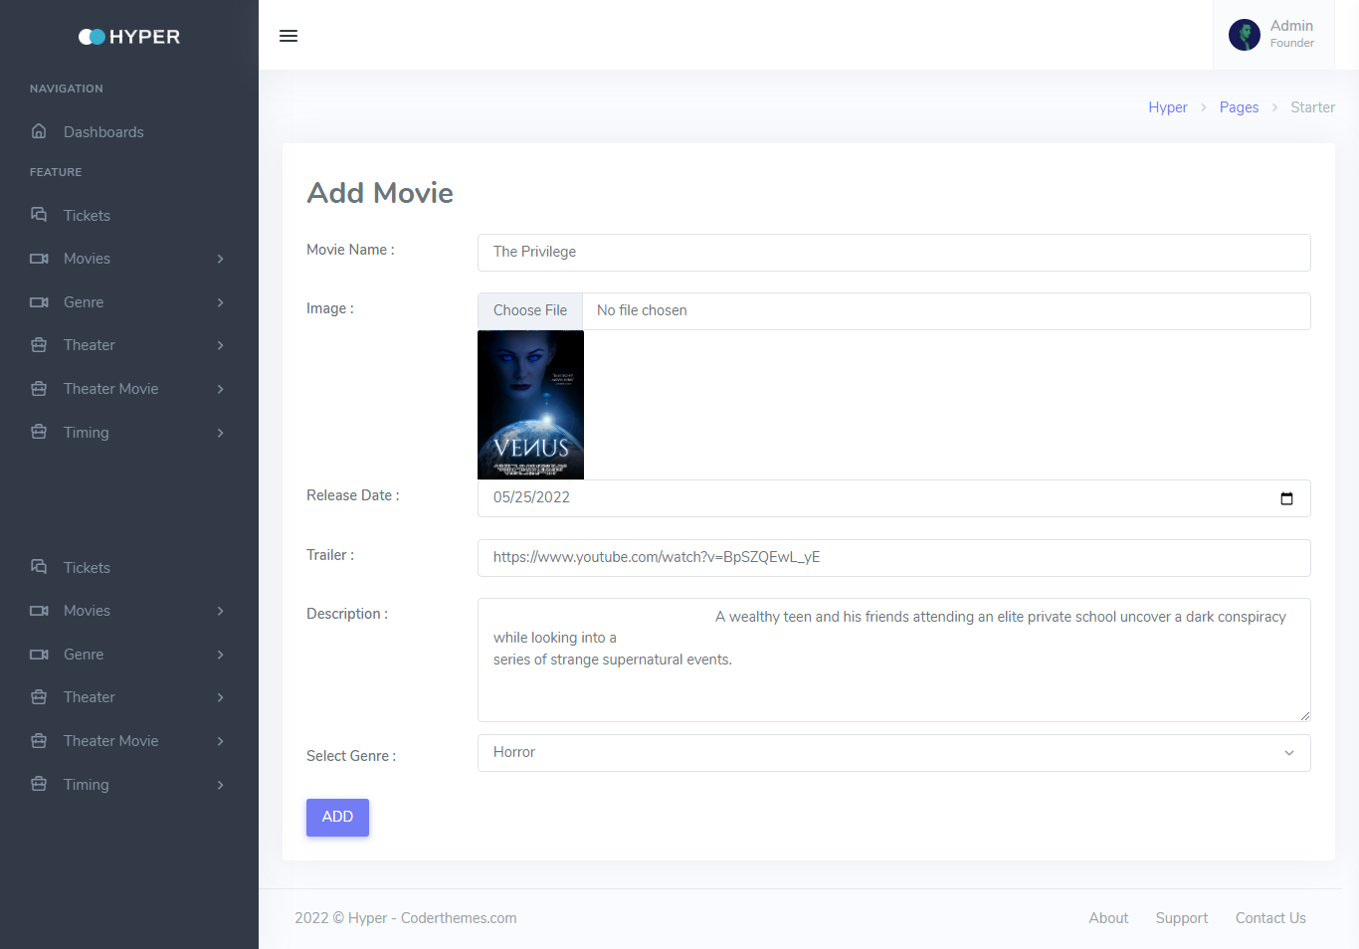

**Tickets:**

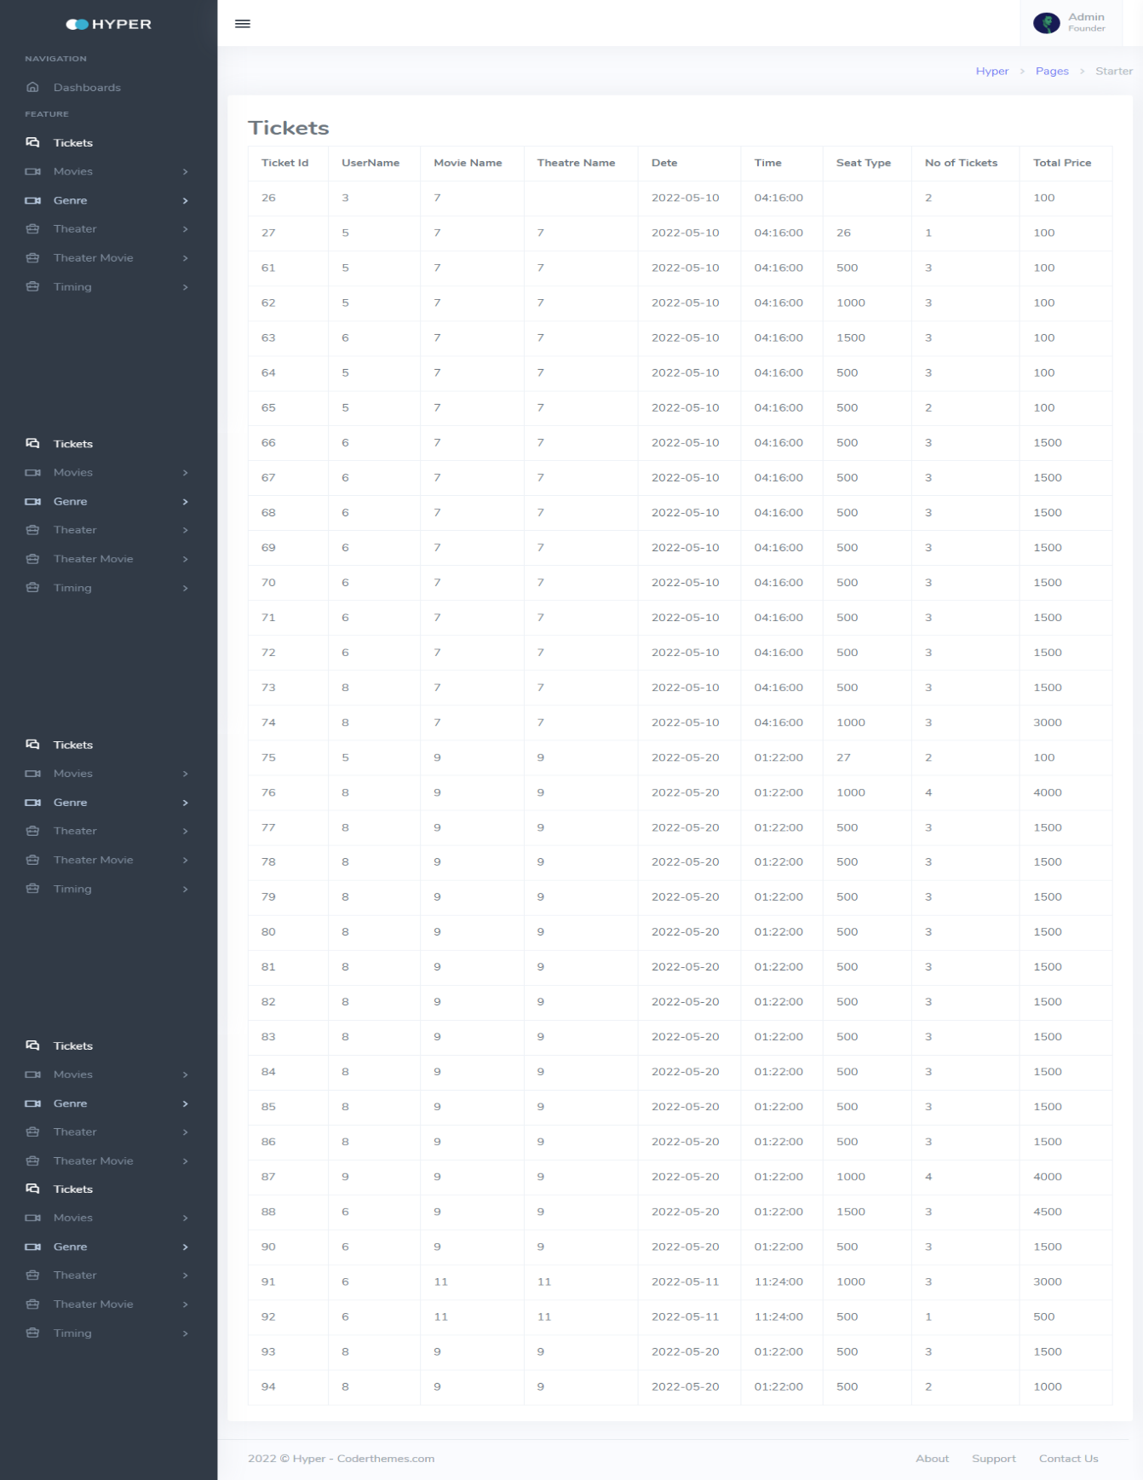

**Timing:**

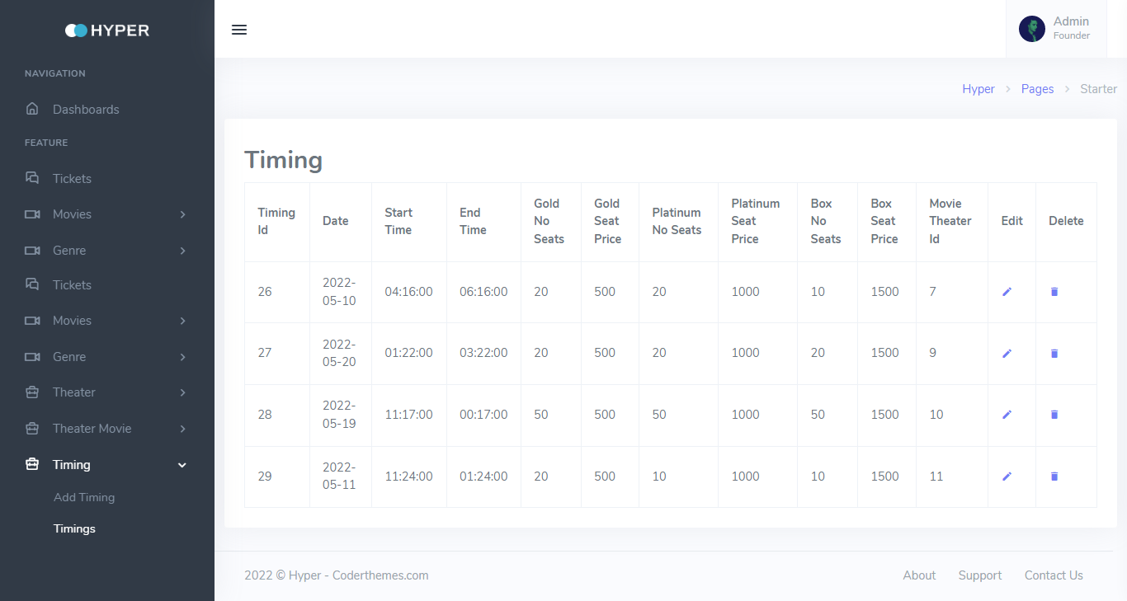**Add Movie:**

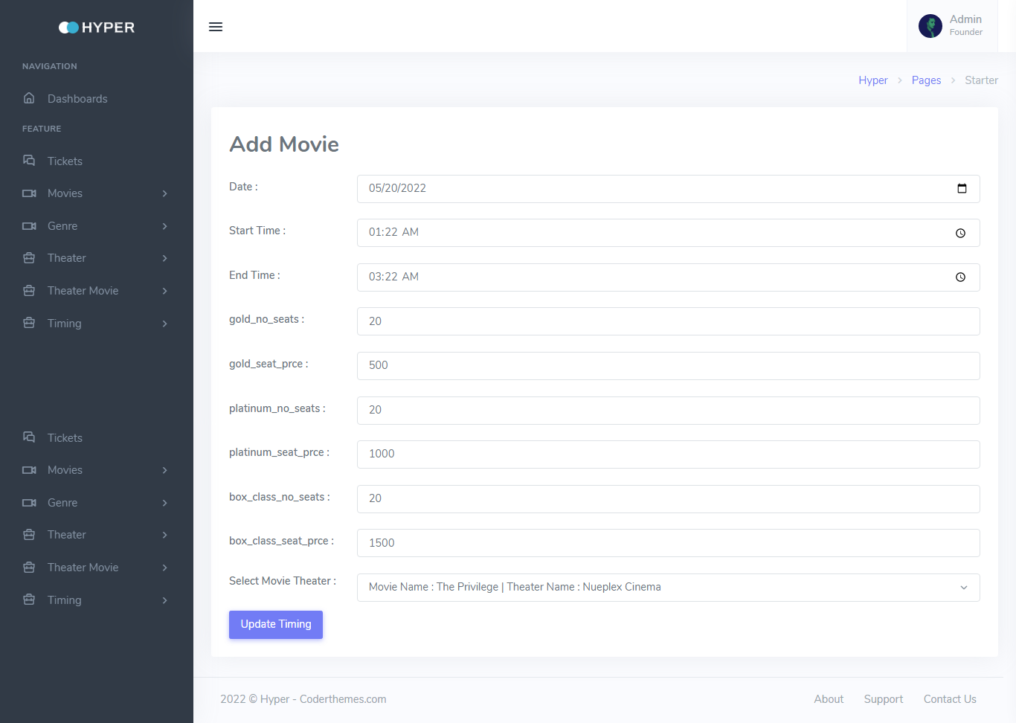

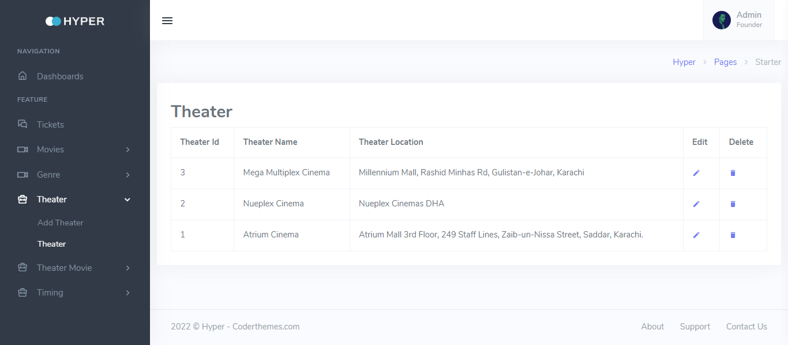**Theatre:**

Database of PHP Project:

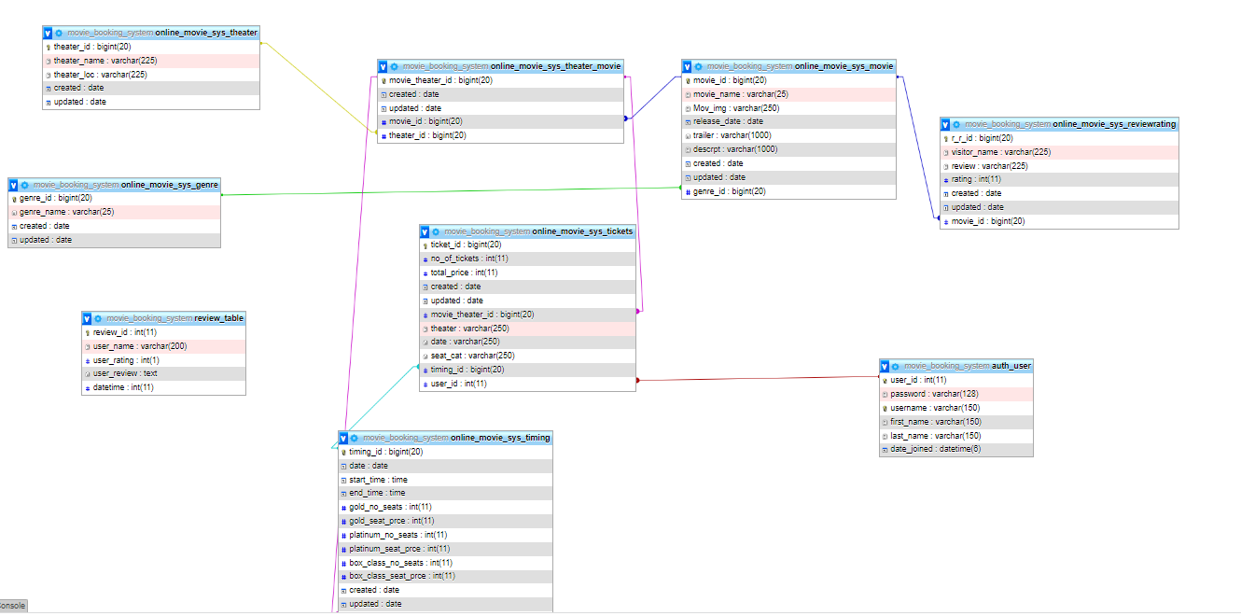

# THE END ….